PRAYER
- Pray for renewed commitment to prayer throughout our Diocese.
- Pray for the work of BCA in Australia.
- Pray for those unwell or in distress at this time, especially Robert & Meryl, Jean, Anna, Liam, Max & Betty, Shirley and Carol.
- Pray for young mother Brooke Barton who is suffering from paralysis.
- Pray that all politicians will deal
compassionately with refugees and seek a solution that reflects Jesus' love for us all. Pray that nations and individuals will compassionately give.
- Give thanks our doctors
- Pray that God is the centre of families and marriages and his presence is felt.
- Give thanks and pray for the work of
Anglicare and the groups they support and who support them.
- Pray for the all the little children suffering illness that they and their families find strength and peace.
- Pray for those affected by Mother Nature around the world, pray for peace and calm and healing in all places.
- pray for the safety of the emergency and armed services personnel
- Pray for the families who have lost loved ones that they may feel God's caring hand on their hearts.
- Pray for peace, calm unity and clarity in Australia and overseas.

Prayer of the day
Brightness of God’s glory, whom death could not conquer nor the tomb imprison:
As you have shared our frailty in human flesh, help us to share your immortality in the Spirit;
Let no shadow of the grave terrify us, and no fear of darkness turn our hearts form you.
Reveal yourself to us this day and all our days, as the First and the Last, the Living One, our immortal Saviour and Lord. . Amen.

Parish Prayer
Heavenly Father, empower us by your Holy Spirit to do your will. Visibly strengthen us to reach out in Christ to others through prayer, worship, study, fellowship, and service, enabling us to share your word and peace.
Help us to grow in love, faith and obedience as we discover meaning, purpose and direction for today and hope for tomorrow through Jesus Christ our Lord. Amen
PARISH DETAILS.
MINISTER: Rev. Jeannie Woollard
OFFICE NO: 5429-1380
Ministers Home Number - preferred contact point
97441026
MINISTER’S MOBILE NO: 0413877906
E-MAIL: jjwoolly@netspace.net.au
Available by request for baptisms, marriage and funerals
HONORARY ASSOCIATE MINISTER:
Rev. Tom Morgan: 5429-6060
(Pew Leaflet by Tuesday to Robyn Cozens)
Ph: 54293429
Email: donegal_consulting@hotmail.com
website: www.lancefieldromseyanglican.org
THE ANGLICAN PARISH OF CHRIST CHURCH LANCEFIELD WITH
ST. PAULS’ ROMSEY.

“Connecting with God and our community.”
"Do what's right and God will do what's left"

1st April 2018 A.D
Easter Sunday
“He is risen”
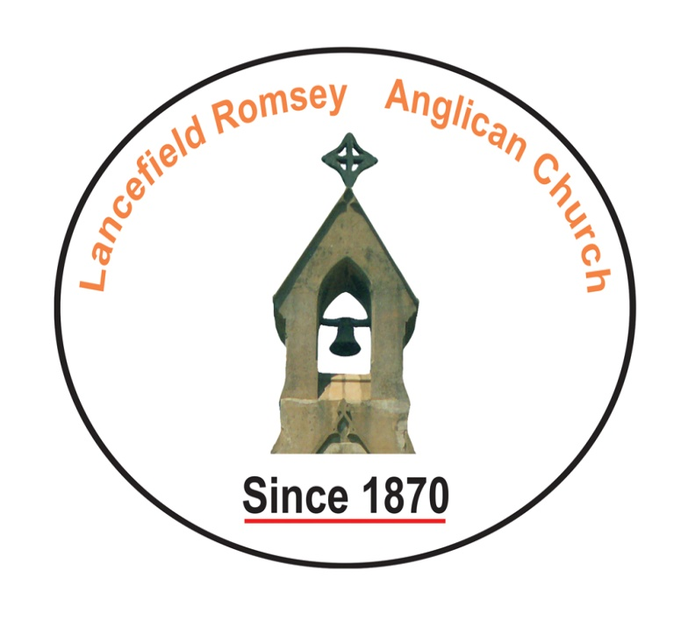
We are glad you are with us.
Before the service, speak to the Lord in prayer
During the service, let the Lord speak to you
After the service, speak to one another

Sentence of Scripture:
The Lord is risen indeed. Alleluia!

BIBLE READING
1st Reading
Small print:
Large Print:
Romsey Reader:
Lancefield reader:
2nd Reading:
Small Print:
Large Print:
Romsey reader:
Lancefield reader:
Gospel Reading
Reader Rev
READINGS FOR NEXT WEEK
SUNDAY 8th April 2018
1st Reading Acts 4:32-37
Small print: Page 521
Large Print: Page 1140
Romsey Reader: Laurie Thomson
Lancefield reader: volunteer
2nd Reading: 1 John 1:1-2:2
Small Print: Page 831
Large Print: Page 1827
Romsey reader: Winifred Mills
Lancefield reader: Volunteer
Gospel Reading John 20:19-31
Reader Rev

ABM Pew Reflection
It is not unmitigated joy; the resurrection is greeted by confusion, fear and even comedy. Yet there is freshness here too, new life being breathed into an old carcass of a world.
- Pray for young churches, those celebrating renewal in their lives and all making a commitment of faith this day.
- Pray for the Amity Foundation in China, giving thanks for the work they do to further God’s mission in the world.
Text: The Very Rev John Roundhill, Dean of Bendigo
© Anglican Board of Mission
Collections
Could you all please save the following items and give to Doreen.
Used stamps – for BCA
Please collect any unused envelopes, any size, shape or colour for Mrs Gayelene Harrower, wife of the former Bp. of Tasmania. She makes greeting cards and sells them for CMS. Doreen
Anglicare
Please remember to purchase for Anglicare when you shop. Every little bit helps

DIARY DATES
Romsey - 8.45 Prayers.
9·ooam service
Lancefield - 10.15am prayer
10.30am service
Tuesday 27th March
10.30am - Bible Study on the book of Genesis Church Hall Lancefield

Sunday 8th April - Bishop Phillip Huggins visiting.
Combined service: 10am at Christ Church Lancefield. Bring a plate to share

Sunday 29th April
Combined Service: 10am Christ Church Lancefield to say bye to Jeannie. Please bring a plate of yummy things to share.

BUSH CHURCH AID
$340 has been forwarded to BCA from the March Box openings - thank you Boxholders for your support of BCA's ministry.
"Go The Distance" to the AGM of BCA and scrumptious Annual Dinner at St.Paul's Boronia..Friday 27th April 2018.
Spit Roast Dinner..$35 per person.
Speaker..Rev. Neville Naden..BCA Indigneous Ministry Officer...
(We can take 3 persons)... Doreen Morgan

