MINISTRY OF THE WORD

A reading from the Prophet Nehemiah.
Now the word of the Lord came to me saying, ‘Before I formed you in the womb I knew you,
and before you were born I consecrated you;I appointed you a prophet to the nations.’
Then I said, ‘Ah, Lord God! Truly I do not know how to speak, for I am only a boy.’ But the Lord said to me,
‘Do not say, “I am only a boy”; for you shall go to all to whom I send you,
and you shall speak whatever I command you.
Do not be afraid of them, for I am with you to deliver you, says the Lord.’
Then the Lord put out his hand and touched my mouth; and the Lordsaid to me,
‘Now I have put my words in your mouth.
See, today I appoint you over nations and over kingdoms,
to pluck up and to pull down, to destroy and to overthrow, to build and to plant.’
Jeremiah 1:4-10
Hear the word of the Lord, thanks be to God
The Epistle is from Paul’s first Letter to the Corinthians

The Gift of Love
If I speak in the tongues of mortals and of angels, but do not have love, I am a noisy gong or a clanging cymbal. And if I have prophetic powers, and understand all mysteries and all knowledge, and if I have all faith, so as to remove mountains, but do not have love, I am nothing. If I give away all my possessions, and if I hand over my body so that I may boast, but do not have love, I gain nothing. Love is patient; love is kind; love is not envious or boastful or arrogant or rude. It does not insist on its own way; it is not irritable or resentful; it does not rejoice in wrongdoing, but rejoices in the truth. It bears all things, believes all things, hopes all things, endures all things. Love never ends. But as for prophecies, they will come to an end; as for tongues, they will cease; as for knowledge, it will come to an end. For we know only in part, and we prophesy only in part; but when the complete comes, the partial will come to an end. When I was a child, I spoke like a child, I thought like a child, I reasoned like a child; when I became an adult, I put an end to childish ways. For now we see in a mirror, dimly, but then we will see face to face. Now I know only in part; then I will know fully, even as I have been fully known. And now faith, hope, and love abide, these three; and the greatest of these is love.
1 Corinthians 13:1-13
May your word live in us, and bear much fruit to your glory

THE GOSPEL

The Lord be with you, and also with you

The Gospel of our Lord Jesus Christ according to Luke 4:21-30

Glory to you Lord Jesus Christ
Then he began to say to them, ‘Today this scripture has been fulfilled in your hearing.’ All spoke well of him and were amazed at the gracious words that came from his mouth. They said, ‘Is not this Joseph’s son?’ He said to them, ‘Doubtless you will quote to me this proverb, “Doctor, cure yourself!” And you will say, “Do here also in your home town the things that we have heard you did at Capernaum.” ’ And he said, ‘Truly I tell you, no prophet is accepted in the prophet’s home town. But the truth is, there were many widows in Israel in the time of Elijah, when the heaven was shut up for three years and six months, and there was a severe famine over all the land; yet Elijah was sent to none of them except to a widow at Zarephath in Sidon. There were also many lepers in Israel in the time of the prophet Elisha, and none of them was cleansed except Naaman the Syrian.’ When they heard this, all in the synagogue were filled with rage. They got up, drove him out of the town, and led him to the brow of the hill on which their town was built, so that they might hurl him off the cliff. But he passed through the midst of them and went on his way.

For the Gospel of the Lord, praise to you Lord Jesus Christ
The New Revised Standard Version (Anglicized Edition), copyright 1989, 1995 by the Division of Christian Education of the National Council of the Churches of Christ in the United States of America. Used by permission. All rights reserved.
WE ASK YOUR PRAYERS THIS WEEK:
For lasting solutions to bring peace to our troubled world: we pray particularly for those parts of the world that are in the news this week. we pray for peace and integrity in all negotiations in international conflicts; and especially for peace in Syria and the Middle East. Hear the cries of the people of Syria; bring healing to those suffering from the violence of Isis and comfort those mourning the dead.

For the sick in our parish, and for those known to us personally
For the faithful departed, remembering those whose years’ mind occurs at this time — May they Rest in Peace and Rise in Glory.

Collections
Could you all please save the following items and give to Doreen.
Used stamps – for BCA

Don’t forget Anglicare in your shopping – every bit helps

Diary Date: Parish Council meets February 17th @ 12 noon in the Lancefield Hall

PARISH DETAILS.
PARISH PRIEST: Rev. Judi Pollard
OFFICE NO: 5429-1830
PARISH PRIESTS MOBILE NO: 0402268001
E-MAIL: judepol@bigpond.net.au
Available by request for baptisms, marriage and funerals
HONORARY ASSOCIATE PRIEST:
Rev. Tom Morgan: 5429-6060
website: www.lancefieldromseyanglican.org
THE ANGLICAN PARISH OF CHRIST CHURCH LANCEFIELD WITH
ST. PAULS’ ROMSEY.
3r^{d} February 2019 A.D
4thSunday after Epiphany
A warm ranges welcome is extended to Bishop Kate Prowd.
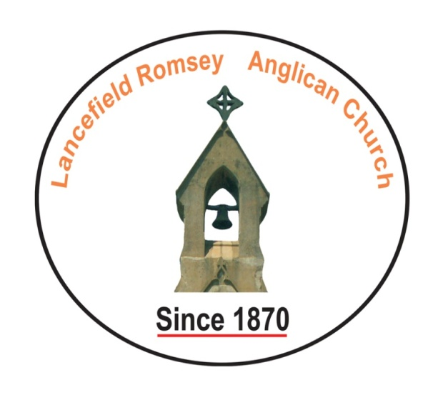
SENTENCE:
Now we see in a mirror, dimly, but then we will see face to face. Now I know only in part; then I will know fully, even as I have been fully known. 1 Corinthians 13:14
Prayer for the Day: Righteous God, You confound the world’s wisdom By giving your blessing to the lowly and pure in heart:
Give us such a hunger and thirst for justice and perseverance in striving for peace, that in our words and deeds the world may see the promise in your kingdom, which has been revealed in Jesus Christ our Lord who lives and reigns with you in the unity of the Holy Spirit one God, for ever and ever. Amen.

