MINISTRY OF THE WORD

**A reading from the Prophet Isaiah.**

For Zion's sake I will not keep silent, and for Jerusalem's sake I will not rest, until her vindication shines out like the dawn, and her salvation like a burning torch. The nations shall see your vindication, and all the kings your glory; and you shall be called by a new name that the mouth of the LORD will give. You shall be a crown of beauty in the hand of the LORD, and a royal diadem in the hand of your God. You shall no more be termed Forsaken, and your land shall no more be termed Desolate; but you shall be called My Delight Is in Her, and your land Married; for the LORD delights in you, and your land shall be married. For as a young man marries a young woman, so shall your builder marry you, and as the bridegroom rejoices over the bride, so shall your God rejoice over you. *Isaiah 62:1-5*

Hear the word of the Lord, ***thanks be to God***

**The Epistle is from Paul’s first Letter to the Corinthians**

Now concerning spiritual gifts, brothers and sisters, I do not want you to be uninformed. You know that when you were pagans, you were enticed and led astray to idols that could not speak. Therefore I want you to understand that no one speaking by the Spirit of God ever says "Let Jesus be cursed!" and no one can say "Jesus is Lord" except by the Holy Spirit. Now there are varieties of gifts, but the same Spirit; and there are varieties of services, but the same Lord; and there are varieties of activities, but it is the same God who activates all of them in everyone. To each is given the manifestation of the Spirit for the common good. To one is given through the Spirit the utterance of wisdom, and to another the utterance of knowledge according to the same Spirit, to another faith by the same Spirit, to another gifts of healing by the one Spirit, to another the working of miracles, to another prophecy, to another the discernment of spirits, to another various kinds of tongues, to another the interpretation of tongues. All these are activated by one and the same Spirit, who allots to each one individually just as the Spirit chooses. *1 Corinthians 12:1-11*

*11*May your word live in us, ***and bear much fruit to your glory***

**THE GOSPEL**

The Lord be with you, ***and also with you***

The Gospel of our Lord Jesus Christ according to **John 2:1-11**

***Glory to you Lord Jesus Christ***

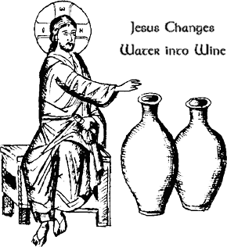  
On the third day there was a wedding in Cana of Galilee, and the mother of Jesus was there. Jesus and his disciples had also been invited to the wedding. When the wine gave out, the mother of Jesus said to him, "They have no wine." And Jesus said to her, "Woman, what concern is that to you and to me? My hour has not yet come." His mother said to the servants, "Do whatever he tells you." Now standing there were six stone water jars for the Jewish rites of purification, each holding twenty or thirty gallons. Jesus said to them, "Fill the jars with water." And they filled them up to the brim. He said to them, "Now draw some out, and take it to the chief steward." So they took it. When the steward tasted the water that had become wine, and did not know where it came from (though the servants who had drawn the water knew), the steward called the bridegroom and said to him, "Everyone serves the good wine first, and then the inferior wine after the guests have become drunk. But you have kept the good wine until now." Jesus did this, the first of his signs, in Cana of Galilee, and revealed his glory; and his disciples believed in him.

For the Gospel of the Lord, ***praise to you Lord Jesus Christ***

*The New Revised Standard Version (Anglicized Edition), copyright 1989, 1995 by the Division of Christian Education of the National Council of the Churches of Christ in the United States of America. Used by permission. All rights reserved.*

***ABM Pew Reflection***

Our closeness to God is what he desires more than anything and the prophet Isaiah expresses this through the image of that sacred institution, Marriage. God’s people are close to him like a bride is close to her bridegroom, and as a bridegroom rejoices over his bride, so God rejoices over his people. Now, we receive so many gifts through the Spirit every day, often without us fully appreciating them or even being aware of them. The goal of these gifts is for us to draw closer to God and to bring others close to him as well. We might like to think about how we can use the gifts we are given to make our salvation ‘shine out like a torch’ and bring more joy to God.

* Pray for the awareness of God’s Spirit active in our lives and in the life of the Church, that we might cultivate and refine our gifts and draw closer to God.
* Give thanks for the Anglican Church of Kenya, remembering especially today the children enrolled in the Catechesis of the Good Shepherd programs.

*Text: The Rev Will Johnston, © Anglican Board of Mission, 2019*

***Collections***

*Could you all please save the following items and give to Doreen.*

***Used stamps – for BCA***

Don’t forget Anglicare in your shopping – every bit helps

**PARISH DETAILS.**

**PARISH PRIEST: Rev. Judi Pollard**

**OFFICE NO: 5429-1830**

**PARISH PRIESTS MOBILE NO:**  0402268001

**E-MAIL:**  judepol@bigpond.net.au

**Available by request for baptisms, marriage and funerals**

**HONORARY ASSOCIATE PRIEST:**

Rev. Tom Morgan: 5429-6060

**(**Pew Leaflet by Thursday to Robyn Cozens)

Email: [donegal_consulting@hotmail.com](mailto:donegal_consulting@hotmail.com)

website: www.lancefieldromseyanglican.org

THE ANGLICAN PARISH OF CHRIST CHURCH LANCEFIELD WITH

ST. PAULS’ ROMSEY.

**20th January 2019 A.D**

**2nd Sunday after Epiphany**

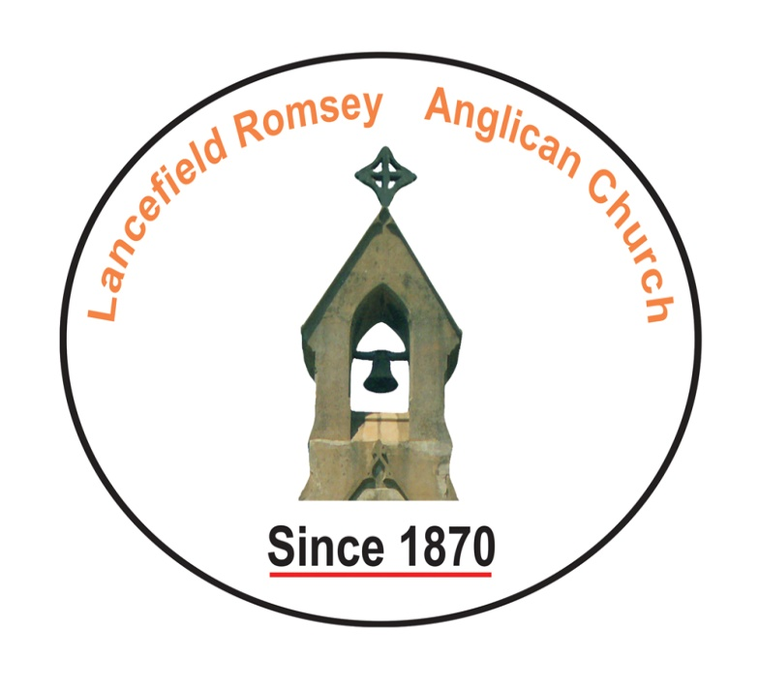

**Sentence of Scripture:**

Jesus revealed his Glory, and his disciples believed in him. John 2:11

**Collect:**

Bountiful God, Whose Son, revealed his Glory at Cana of Galilee:

Help us to believe and obey, so that, as our saviour promised, we may be filled with the wine of new life And show forth his joy and love;

who lives and reigns with you in the unity of the Holy Spirit one God, now and for ever. **Amen**